**Shashwat Tripathi**

**D10A 58**

**BATCH: C**

**PYTHON LAB**

**Exp No: 4**

**AIM:** Write python programs to understand

a) Creating User-defined modules/packages and import them in a program.

b) Python program to illustrate the concept of threading importing the threading module.

c) Creating a menu driven application which should cover all the built-in exceptions in python.

**CODE:**

**Math Module**

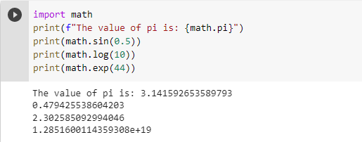

**OS Module**

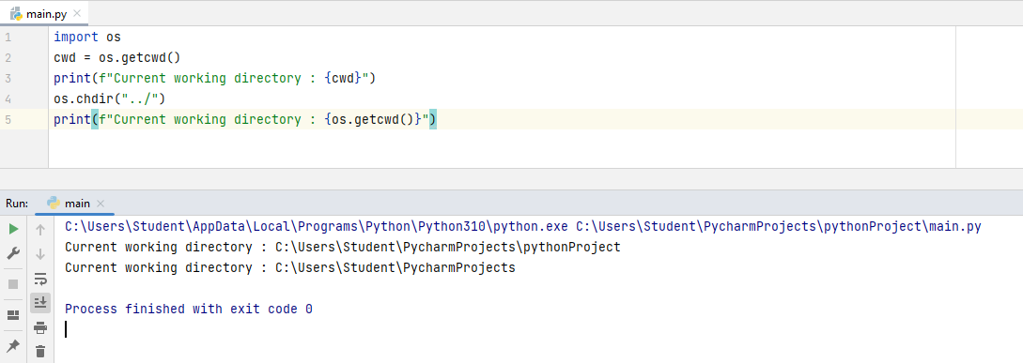

**SYS Module**

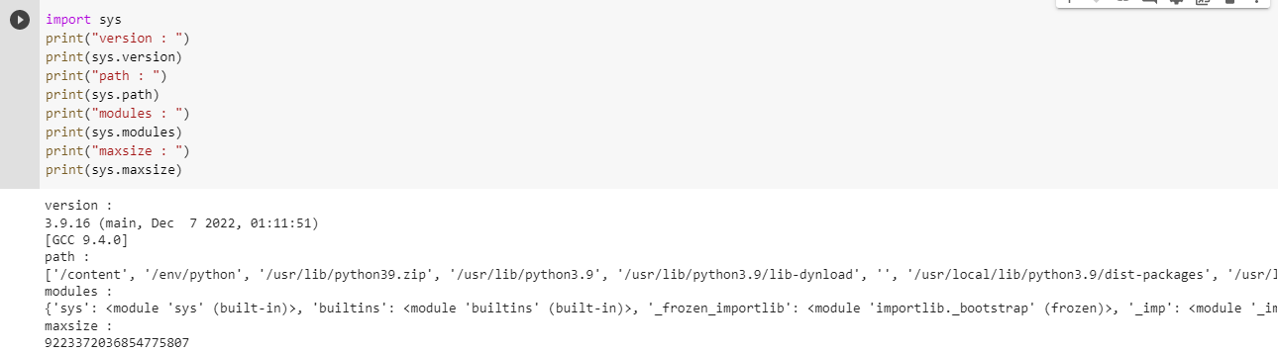

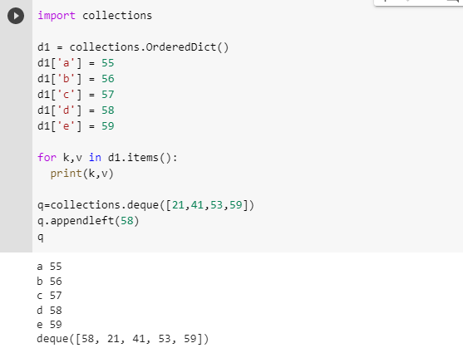

**Random Module**

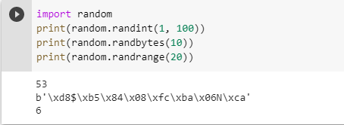

**Regular expression module**

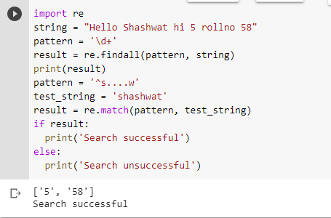

**Threading**

